Abhishek Gupta

Dr. David Ruby

CSCI 174

10 September 2017

**Assignment 1: CodeEval Bay Bridges Challenge**

**General Problem Description**

As stated in the challenge description on CodeEval, there has emerged a novel technological breakthrough to allow the modification of bridges to withstand a 9.5 magnitude earthquake at a significantly reduced cost and time. Rather than fully equipping bridges with this technology (which would take too long and cost too much), we want to only target strategic coordinates of where this technology would prove beneficial.

**Technical Problem Description**

The goal is to connect as many pairs of points as possible with bridges such that no two bridges cross. When connecting points, you can only connect point 1 with another point 1, point 2 with another point 2, etc.

Our program will take in a file as an argument. Inside that file, we will have coordinates that might look like the following:

C:\Users\joopj\AppData\Local\Microsoft\Windows\INetCache\Content.Word\li.png

1, 2, 3, 4, 5, and 6 each represent a line. Once our program finishes reading and processing this txt file, it will output into the console:

C:\Users\joopj\AppData\Local\Microsoft\Windows\INetCache\Content.Word\li.png

What this means is that 1, 2, 3, 5, and 6 are the only valid lines because they do not intersect other lines. Why is 4 not included? Because it intersects lines 5 and 6. Let’s take a closer look by graphing the above lines to see what we mean:

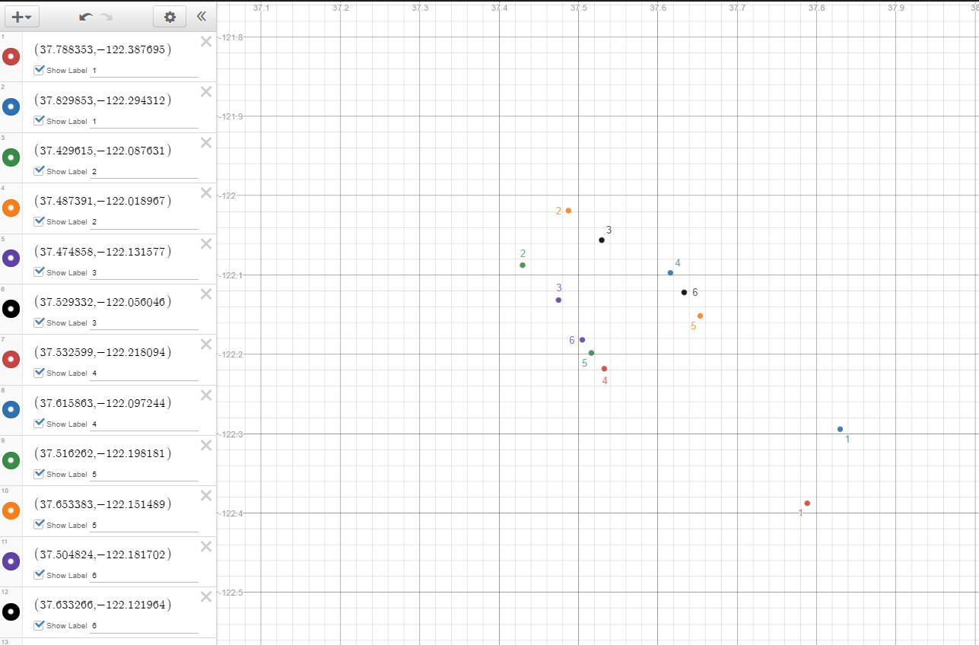From the graph above, we see that lines 1, 2, and 3 are valid as they do not intersect other lines. However, line 4 intersects 5 and 6. Since 4 intersects the most lines, it is not valid in our output solution. 5 and 6 are valid once 4 is removed.

**Solution Design**

Our program must take in a txt file argument with sample input that complies with the formatting provided in “INPUT SAMPLE 1.” It must distinguish line labels (1, 2, 3, etc.) and identify that each label has 2 coordinates in the format ([x1, y1], [x2, y2]). The key here is that we don’t just want to toss a line out if it has an intersection. Otherwise, 5 and 6 would not be valid lines because they each have an intersection with 4. Rather, we need to find the largest set of lines where there exists no intersection.

To solve this problem, I will break it down into several sub-problems until I can find a sub-problem that I can solve. I will then use this solution to solve all sub-problems so that I can combine the solutions into a working program for this challenge.

The first sub-problem I am going to solve is how to find out if 2 lines intersect.

**Works Cited**

1. Article: Line Segment Intersection Algorithm (Article + Comments Section)  
   http://bryceboe.com/2006/10/23/line-segment-intersection-algorithm/  
   Purpose: Shows code on how to determine if 2 lines intersect.
2. Article: The Key to Solving CodeEval’s Bay Bridge Problem  
   http://deepinthecode.com/2014/03/26/key-solving-codeevals-bay-bridges-challenge/  
   Purpose: Does a better job in explaining what problem we are trying to solve.
3. Article: Bay Bridges Challenge (solved!) https://shashankr.wordpress.com/2014/03/10/bay-bridges-challenge-solved/  
   Purpose: Goes over the problem in depth. Provides a mathematical proof for the solution.